Design Patterns

Command Pattern:
According to the book Design Patterns, the Command design pattern "encapsulates a request as an object, thereby letting you parameterize clients with different requests, queue or log requests, and support undoable operations."

http://www.codeproject.com/Articles/28309/Design-pattern-FAQ-Part-1-Training#Canyouexplaincommandpatterns

http://www.dofactory.com/Patterns/PatternCommand.aspx#_self1

This design pattern states to bind a command in form of an object which adheres to a know Interface. This object has an excecute method and a constructor. Set all the references of objects required to execute the command in the constructor method. This pattern can also be used to queue the commands. There is an invoker oject used to invoke the commands (also provided a queing mechanism), also provides a mechanism to undo command. Invoker basically puts all the defined command objects in an array and provides a mechanism to return the correct command object requested by the client code (depending on a parameter.), the client code then executes the command by using the execute method.

A concrete command class will often implement a parameterized constructor to accept the necessary arguments to set some or all of its properties, as shown:

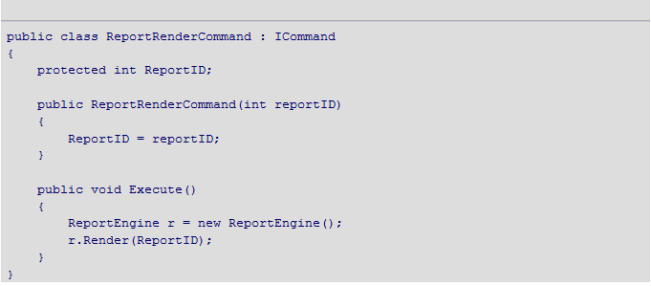
Just pass the invoker the appropriate command object, the invoker will execute it immediately or in a queued fashion.

Singleton:
Assure an single object is only created. To assure the creation of a single object:
- make the constructor private.
- Provide a static method (eg. getInstance) in the class which can be called by the client code, the static method calls the private constructor to create the object.
- The static method uses an internal static variable (flag) to ensure that only one object is created at any time.

Singleton = Single means single object across the application life cycle & the scope of singleton is at application level.
Static= Staticc an not have any object pointer & the scope of static is at App Domain level.

singleton can extend classes and implement interfaces, while a static class cannot (it can extend classes, but it does not inherit their instance members).
If there are bunch of functions should be kept together, then static is the choice. Anything else which needs single access to some resources, could be implemented singleton.
Unlike static classes, we can use singletons as parameters or objects
Reusing the singleton. Here we can use the singleton on any method that accepts the interface
Singletons allow you to reuse code and control object state much easier. This improves code-sharing, and can result in a far cleaner body of code. With less code, your programs will usually have fewer bugs and will be easier to maintain.
Singleton on the other hand provides flexibility and also provides sort of a mechanism to control object creation based on various requirements

The Decorator pattern provides us with a way to modify the behavior of individual objects without having to create a new derived class.
Suppose we have a program that uses eight objects, but three of them need an additional feature. You could create a derived class for each of these objects, and in many cases this would be a perfectly acceptable solution. However, if each of these three objects requires different features, this
would mean creating three derived classes. Further, if one of the classes has features of both of the other classes, you begin to create complexity that is both confusing and unnecessary.

For eg: Two or three classses are derived fom a abstract classs, each containing it own functionality [eg display functionality] now a speciall functionality is needed by one or more of the above classes, (which is common to both, but not all, and which is occasionally required in special casses].
In this case have a abstract decorator class which is again derived from the same abstract base class (used as a base class for the classes to be decorated). But the functionality in that class, which also executes the functionality from the base class as well. In the constructor of the decorator class we register the class to be decorated.
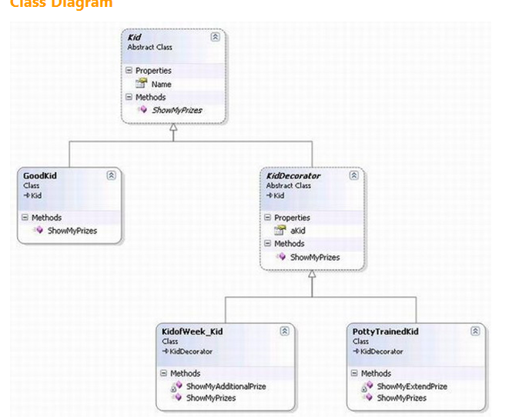
For mulitple deceorator functionalities multiple decorator classes can be implemented.
[ref: Design pattern in C# pdf]
http://www.dofactory.com/Patterns/PatternDecorator.aspx
Facade Pattern
Implemented in VPI project. The WCF service was calling a Facade object for desired functionality, the service need not have knowledge of all the objects associated with the request.
Provide a unified interface to a set of interfaces in a subsystem. Façade defines a higher-level interface that makes the subsystem easier to use.
The facade as the knowledge (or instantiates) of the necessary objects and acts upon them giving the necessary results.
http://www.dofactory.com/Patterns/PatternFacade.aspx

Observer Pattern:
Two objects
- Subject
- Observer

Observer implements a interface which contains a common method to be excecuted when the event occurs. The Observer has to be registered with the subject in the constructor. Whenever the change occurs in the subject, the event is raised and all the observer objects are informed.

The Chain of Responsibility is a good example of a pattern that helps keep
knowledge separate of what each object in a program can do. In other
words, it reduces the coupling between objects so that they can act
independently. This also applies to the object that constitutes the main
program and contains instances of the other objects. You will find this
pattern helpful in the following situations.
• There are several objects with similar methods that could be appropriate for the action the program is requesting. However, it is more appropriate for the objects to decide which one is to
carry out the action than it is for you to build this decision into the calling code.
One of the objects may be most suitable, but you don’t want to build in a series of if-else or switch statements to select a particular object.
• There might be new objects that you want to add to the possible list of processing options while the program is
executing.
• There might be cases when more than one object will have to act on a request, and you don’t want to build knowledge of these interactions into the calling program.

Dependency Injection Pattern
http://www.codeproject.com/Articles/60844/Dependency-Injection-in-NET

also knows as Inversion of Control,

The basic idea behind Dependency Injection is that you should isolate the implementation of an object from the construction of objects on which it depends

In general if a class example the buissness Façade class is depended on certain business logic class, or Class responsible for storing cache functionaliy, you don’t create the object directly, but inject it in the façade class, via its contructor or property…so the calling code or client code has the control over which business logic class would be used in runtime, generally people would use utilities like structure map, which is a ready library for factory pattern, this way the dependency can be specified in the Configuration file, and can be changed any time without recompiling the code..thats what omar had done in VPI project, he specified the cache library in the configuration file..

Also instead of specifying concrete class for dependency, they are specified via interfaces…

Generally constructor injection should be used instead of property injection, if the injection need not be changed again and again at runtime…

Dependency Injection is a form of the Inversion of Control Pattern where a factory object carries the responsibility for object creation and linking. The factory object ensures loose coupling between the objects and promotes seamless testability.
This is where a dependency injection steps in and allows you to:
- Specify a class's dependency at run-time
- Dynamically use classes in another assembly
- Make changes without recompilation
What is Dependency Injection?
Dependency injection eliminates tight coupling between objects to make both the objects and applications that use them more flexible, reusable, and easier to test. It facilitates the creation of loosely coupled objects and their dependencies. The basic idea behind Dependency Injection is that you should isolate the implementation of an object from the construction of objects on which it depends. Dependency Injection is a form of the Inversion of Control Pattern where a factory object carries the responsibility for object creation and linking. The factory object ensures loose coupling between the objects and promotes seamless testability.

Types of Dependency Injection
There are three common forms of dependency injection:
- Constructor Injection
- Setter Injection
- Interface-based injection

Repository Pattern
http://www.asp.net/mvc/tutorials/getting-started-with-ef-using-mvc/implementing-the-repository-and-unit-of-work-patterns-in-an-asp-net-mvc-application
http://msdn.microsoft.com/en-us/library/ff847525.aspx
http://martinfowler.com/eaaCatalog/repository.html
http://martinfowler.com/eaaCatalog/repository.html
http://www.codeproject.com/Articles/526874/Repositorypluspattern-2cplusdoneplusright

Repository basically sits between the Business layer and DB layer (i.e. the routines supposed to call Database stored procedures for insertion, updation, retrieval etc.) The business layer call the repository of the specific business entity to do database operations just passing the Buisness object, it does not has to worry about how the operations are done inside, that is the objective of the repository. In Domain - Driven Design, there are two types of Factories, those for building the root Entity of an Aggregate (usually from some type of resultset data) and those for building Value objects (usually from some type of configuration data).

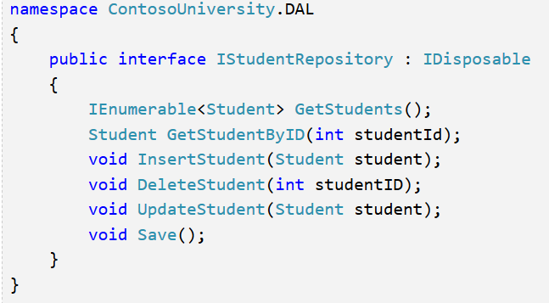

This would be general implentation of the repository. There can be other helper classes like field mappers etc..helping the repository internally.
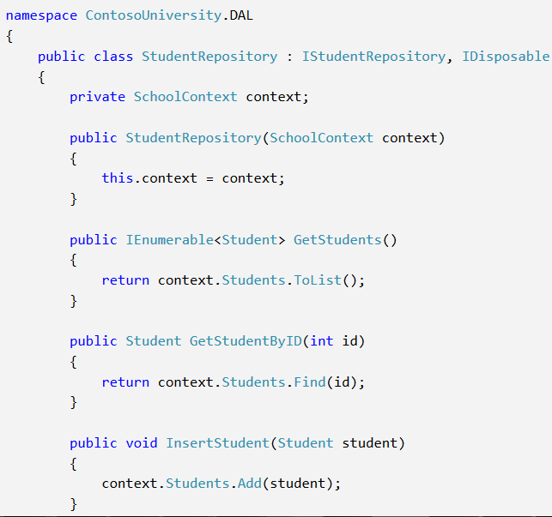
As seen above the repository is also needed betn the Entity framework and the buisness layer to create one more layer of abstraction. The repository class call the entity framework methods internally.

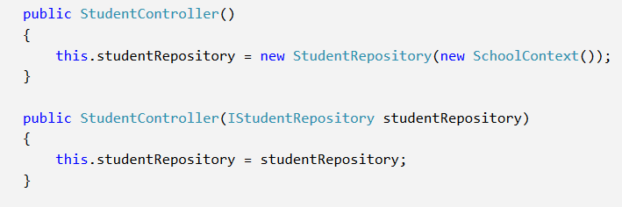
The repository is used as above (generally the buissness façade layer ), first setting the context..
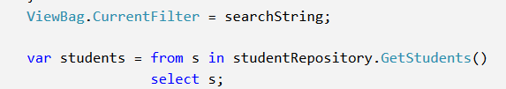

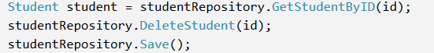

Unit OF Work
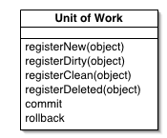
Creating a repository class for each entity type could result in a lot of redundant code, and it could result in partial updates. For example, suppose you have to update two different entity types as part of the same transaction. If each uses a separate database context instance, one might succeed and the other might fail. One way to minimize redundant code is to use a generic repository, and one way to ensure that all repositories use the same database context (and thus coordinate all updates) is to use a unit of work class.
The unit of work class serves one purpose: to make sure that when you use multiple repositories, they share a single database context. That way, when a unit of work is complete you can call the SaveChanges method on that instance of the context and be assured that all related changes will be coordinated. All that the class needs is a Save method and a property for each repository. Each repository property returns a repository instance that has been instantiated using the same database context instance as the other repository instances.
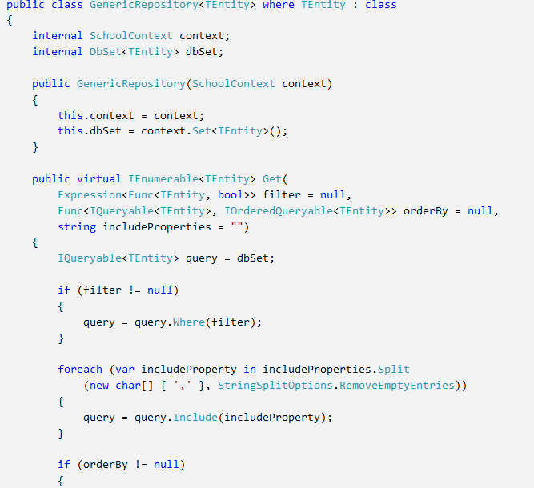
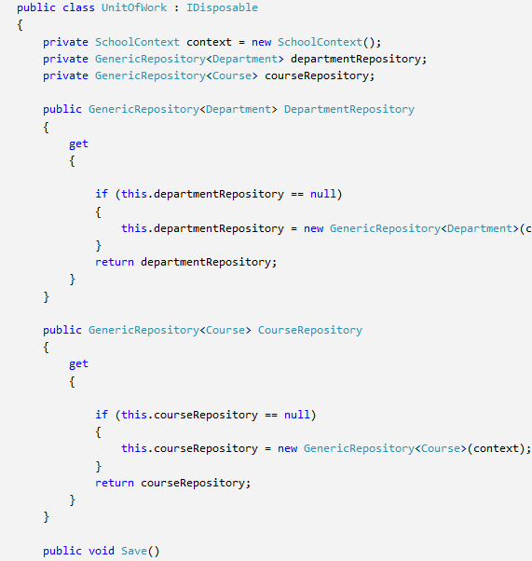
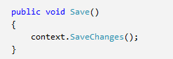

Then the unitofwork class is used by the buisness layer, access the appropriate repository which is one of the object property of the UnitOfWork class…and the approriate method (i.e insert etc) is called for the relevant operation.
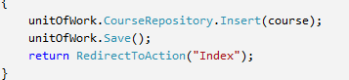

Using the repository pattern makes the application..over all testable (using nunit etc),,,it is not dependent on the availability of the database,,,one can use mock classes (which would insert the data in some in memory collection instead of database..thus the buissness layer functionality is tested independent of availability of database connection).

Identity Map
This pattern or class makes sure that only one object is created (for e.g. only one object is created for one customer id). The identity map class stores the keys of all objects of all classes..and then next any object is created for the same customerid, it first checks if the object for that customer id is already instantiated if yes,,it returns the same object..thus if multiple objects for same id are created by different parts of the application..same object is modified..instead of modifying multiple copies and changes being overridden.
http://msdn.microsoft.com/en-us/magazine/dd569757.aspx#id0400073
http://www.c-sharpcorner.com/uploadfile/rmcochran/C-Sharp-generic-identity-map-creating-an-object-pool-for-multiple-object-types/
http://rlacovara.blogspot.in/2009/03/entity-framework-patterns-identity-map.html

An Identity Map keeps a record of all objects that have been read from the database in a single business transaction. Whenever you want an object, you check the Identity Map first to see if you already have it.

Dumping objects (refer to the dump.cs in omar’s code)..
http://www.codeguru.com/csharp/csharp/cs_syntax/reflection/article.php/c14531/NET-Tip-Display-All-Fields-and-Properties-of-an-Object.htm

.NET Tip: Display All Fields and Properties of an Object
Top of Form
Visual Studio provides a wealth of information in a way that does not get in the way and are an invaluable asset when debugging. There are times, however, when looking at objects during an interactive debugging session isn't appropriate. I work with applications that may have multiple things happening on a timed basis as well as data coming in and raising events in a manner that the timing can't be controlled. Sometimes, the act of debugging itself changes that timing and the problem goes away or is masked during an interactive debugging session.
In this situation, I need to dump the state of several objects before and after some event takes place to determine what is happening. I think the easiest way to do this is by using reflection to have an object dump its own state. I have created a static method in a utility class that takes an Object and returns a string including the type of the object as well as the values of all of the object's fields and properties. Here is the method I use

Immutable objects
http://msdn.microsoft.com/en-us/library/bb383979.aspx
http://codebetter.com/patricksmacchia/2008/01/13/immutable-types-understand-them-and-use-them/
When objects once created cannot be modified.
One can create an immutable object in csharp by having private properties..the class can be instantiated via constructor only or a factory method..refer to code below
Why immutable objects?
Eg. String..
So we now know at least 3 great benefits of immutable objects:
- They simplify multithreaded programming.
- They can be used as hashtables key.( without risk of corrupting the hash data structure, and is needed for .Net security reasons)_
- They simplify state comparison.
Varsha book depot sec 17 27896049 27897079/4475
9323585161

// This class is immutable. After an object is created,
// it cannot be modified from outside the class. It uses a
// constructor to initialize its properties.
class Contact
{
// Read-only properties.
public string Name { get; private set; }
public string Address { get; private set; }

// Public constructor.
public Contact(string contactName, string contactAddress)
{
Name = contactName;
Address = contactAddress;
}
}

// This class is immutable. After an object is created,
// it cannot be modified from outside the class. It uses a
// static method and private constructor to initialize its properties.
public class Contact2
{
// Read-only properties.
public string Name { get; private set; }
public string Address { get; private set; }

// Private constructor.
private Contact2(string contactName, string contactAddress)
{
Name = contactName;
Address = contactAddress;
}

// Public factory method.
public static Contact2 CreateContact(string name, string address)
{
return new Contact2(name, address);
}
}

UI (presentation layer) — Probably the easiest to understand, this layer is responsible for
showing information to the user and interpreting the user ’ s commands. Sometimes, instead of a
human, the user could be another system.
❑ Application layer — This layer is meant to be very thin and is used for coordinating the actions
of the domain model objects. It is not supposed to contain business rules or domain knowledge,
or even maintain state — that is what the domain model is for. The application layer is very
useful for coordinating tasks and delegating actions to the domain model. Although it is not to
be used to maintain state of a business entity, it can maintain the state that tracks the current
task being performed by the user or system. It is very important that the application layer does
not interfere or get in the way of the domain model representing the important parts of the
business model ( http://weblogs.asp.net )
Domain layer — This is where the business logic and rules of an application live, and it is the
heart of the software. The domain layer controls and uses the state of a particular business
concept or situation, but how it is stored is actually delegated to the infrastructure layer. It is
absolutely critical in Domain - Driven Design that the domain layer contains the business model,
and that the domain logic is not scattered across any other layers.
❑ Infrastructure layer — This is where general technical, plumbing - related code happens, such as
persisting objects to a database, sending messages, logging, and other general cross - cutting
concerns. It can also serve as a place for an architectural framework for the pattern of interactions
between the four layers.

If I am successful, a domain model class can talk to a repository interface if it really needs to, yet the
implementation of the actual repositories will be in the infrastructure layer. This is better known as
the Separated Interface pattern (Fowler, Patterns of Enterprise Application Architecture , 476 – 479), where the
interface is defined in a separate assembly from its implementation.

Layer SuperType pattern explained.

A type that acts as the supertype for all types in its layer.

This is one of the easiest and simple to understand pattern. We will consider data access layer for explaining this pattern. In the data access layer each class performs some database calls for retrieving/updating the data, rather than each class redefining the data access behavior we will move this responsibility to a separate class (super class) and make sure all the classes in this layer inherit the super class for the common data access behavior.
Having all entities inherit from an entity base class type will help eliminate some duplicate properties and behavior
in the domain entity classes. The use of this base class is purely for convenience, and I feel that it will not
distract our model at all; in fact, it will be easier to distinguish between which classes are entities and
which ones are value objects.

============================================================================
E:\Projects Done\VPI Quote & Entrollment\Root\EnterpriseServices\VPI.EnterpriseServices.Infrastructure\Domain\EntityBase.cs
E:\Projects Done\VPI Quote & Entrollment\Root\EnterpriseServices\VPI.EnterpriseServices.Infrastructure\Repositories\IRepository.cs

put all of the Find type of methods in Aggregate - specific
types of repositories, an example of which would look like the IProjectRepository interface shown
below:

